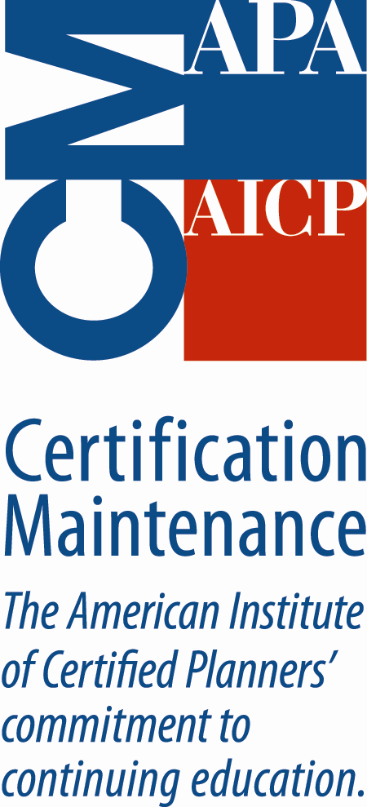
ToP® Facilitation Methods Training

Public Participation - Professional Development
Receive CM I 14.5 for the two day training

To register: http://www.ica-usa.org
For information: greenschemes@bellsouth.net
September 17-18, Hendersonville, NC
Hendersonville Dispute Settlement Center

“Within a week of my training, I was asked to do a consensus-building workshop
in a public setting for a major municipal infrastructure retrofit. With my newly
developed skills and the mentoring of the ToP® trainer, I was able to successfully
coordinate input and develop consensus in a meeting of over 50 area residents!
This would not have happened without the use of ToP® methods.”
M. James Riordan, AICP, LEED-AP

“ToP® Facilitation Methods is a fantastic training opportunity. As a consultant
who handles public engagement and comprehensive planning for a mid-sized firm,
I could not imagine a more pertinent subject to learn. The course materials were
presented in an excellent format. By far, this was the best professional
development opportunity I have taken advantage of as a planner.”
Scott A. Dunakey, AICP

